Doctype –

<!doctype html> (often written as <!DOCTYPE html>) is a declaration that goes at the very top of an HTML file.

Here’s what it does:

* **Tells the browser what version of HTML you’re using**  
  In modern web pages, writing <!doctype html> tells the browser: *“This page is written in HTML5.”*
* **Helps the browser render the page correctly**  
  Without it, the browser might switch into something called “quirks mode,” where it tries to behave like very old browsers (from the late 1990s). That can cause layout problems.
* **Not a tag, just an instruction**  
  Unlike <html>...</html> or <body>...</body>, the <!doctype> isn’t an HTML element. It’s just a rule at the very top, giving the browser instructions.

👉 In short: <!doctype html> = a little flag at the top that says *“This is a proper HTML5 document—please render it with modern rules.”*

For **HTML5, 5.1, and 5.2**, you always write:

<!DOCTYPE html>

That’s it—short, simple, and the same across all of them.

The reason: the doctype in modern HTML isn’t version-specific anymore. It just tells the browser “use standards mode” (the modern rules), not which sub-version of HTML5 you’re on.

👉 So whether you’re on 5.0, 5.1, 5.2, or the current HTML Living Standard, the doctype line is **always the same**

**Modern HTML (HTML5, 5.1, 5.2, Living Standard)**

<!DOCTYPE html>

* Super short and universal.
* Doesn’t specify a version, just says “standards mode please.”

**🟢 HTML 4.01 Strict**

<!DOCTYPE HTML PUBLIC "-//W3C//DTD HTML 4.01//EN"

"http://www.w3.org/TR/html4/strict.dtd">

* “Strict” means no deprecated tags (like <font>).
* Tied to a *Document Type Definition (DTD)* file.

**🟡 HTML 4.01 Transitional**

<!DOCTYPE HTML PUBLIC "-//W3C//DTD HTML 4.01 Transitional//EN"

"http://www.w3.org/TR/html4/loose.dtd">

* Transitional allowed old/deprecated tags for backward compatibility.

**🔵 HTML 4.01 Frameset**

<!DOCTYPE HTML PUBLIC "-//W3C//DTD HTML 4.01 Frameset//EN"

"http://www.w3.org/TR/html4/frameset.dtd">

* Special doctype if you used <frameset> instead of <body>.

**🟣 XHTML 1.0 Strict**

<!DOCTYPE html PUBLIC "-//W3C//DTD XHTML 1.0 Strict//EN"

"http://www.w3.org/TR/xhtml1/DTD/xhtml1-strict.dtd">

* XML-based flavor of HTML.
* Required stricter, well-formed syntax (lowercase tags, closing every element, etc.).

| **Version** | **Doctype Declaration** |
| --- | --- |

|  |  |
| --- | --- |
| **HTML5 / 5.1 / 5.2 / Living Standard** | html<br><!DOCTYPE html><br> |

|  |  |
| --- | --- |
| **HTML 4.01 Strict** | html<br><!DOCTYPE HTML PUBLIC "-//W3C//DTD HTML 4.01//EN"<br> "http://www.w3.org/TR/html4/strict.dtd"><br> |

|  |  |
| --- | --- |
| **HTML 4.01 Transitional** | html<br><!DOCTYPE HTML PUBLIC "-//W3C//DTD HTML 4.01 Transitional//EN"<br> "http://www.w3.org/TR/html4/loose.dtd"><br> |

|  |  |
| --- | --- |
| **HTML 4.01 Frameset** | html<br><!DOCTYPE HTML PUBLIC "-//W3C//DTD HTML 4.01 Frameset//EN"<br> "http://www.w3.org/TR/html4/frameset.dtd"><br> |

|  |  |
| --- | --- |
| **XHTML 1.0 Strict** | html<br><!DOCTYPE html PUBLIC "-//W3C//DTD XHTML 1.0 Strict//EN"<br> "http://www.w3.org/TR/xhtml1/DTD/xhtml1-strict.dtd"><br> |

|  |  |
| --- | --- |
| **XHTML 1.0 Transitional** | html<br><!DOCTYPE html PUBLIC "-//W3C//DTD XHTML 1.0 Transitional//EN"<br> "http://www.w3.org/TR/xhtml1/DTD/xhtml1-transitional.dtd"><br> |

|  |  |
| --- | --- |
| **XHTML 1.0 Frameset** | html<br><!DOCTYPE html PUBLIC "-//W3C//DTD XHTML 1.0 Frameset//EN"<br> "http://www.w3.org/TR/xhtml1/DTD/xhtml1-frameset.dtd"><br> |

|  |  |
| --- | --- |
| **XHTML 1.1** | html<br><!DOCTYPE html PUBLIC "-//W3C//DTD XHTML 1.1//EN"<br> "http://www.w3.org/TR/xhtml11/DTD/xhtml11.dtd"><br> |

**🏗️ Old way: DTDs (Document Type Definitions)**

* In **HTML4 and XHTML**, the doctype pointed to a **DTD file** on the W3C website.
* That DTD described the rules: what tags were allowed, in what order, and with what attributes.
* Browsers would use the doctype mostly to decide if they should render in **standards mode** or **quirks mode**.
* In practice, browsers didn’t actually download and validate your HTML against those DTDs (that would’ve been way too slow).

**🚀 HTML5 shift: no more DTDs**

* The HTML5 working group realized DTDs were basically *ceremonial*.
* Browsers just needed a “flag” to know:
  + **Strict standards mode** (modern layout rules)
  + or **quirks mode** (old legacy layout hacks)
* So they ditched the long DTD references and made it **super short**:
* <!DOCTYPE html>

**✨ Benefits of the new system**

1. **Cleaner**: No scary-looking URL strings at the top of your code.
2. **Universal**: Same doctype works for HTML5, HTML5.1, 5.2, and even today’s **Living Standard**.
3. **Future-proof**: You don’t have to update your doctype whenever a new HTML version comes along.
4. **Still does the job**: Tells the browser “use standards mode,” which is all that really matters.

So basically:

* Old doctypes = dusty rulebooks nobody really used 📚.
* HTML5 doctype = just a **light switch** that says “turn on modern mode.” 💡

If you **forget the <!DOCTYPE html>**, browsers don’t just throw an error. Instead, they switch into what’s called **“quirks mode.”**

**🕹️ Two Rendering Modes in Browsers**

**1. Standards Mode (with doctype)**

* Browser follows modern web standards (CSS box model, flexbox, modern layout rules).
* What you write is what you get, consistent across browsers.

**2. Quirks Mode (without doctype, or with old/invalid doctype)**

* Browser tries to mimic the behavior of **very old browsers** (Netscape 4, IE5).
* It was added so old, messy websites from the 90s wouldn’t completely break.
* Causes layout differences:
  + **Box model bug**: In quirks mode, width includes padding + border (IE5 behavior), while in standards mode, width is just the content box.
  + Some CSS units behave oddly.
  + Line heights, table layouts, and positioning can render unpredictably.

<html>

<head>

<style>

div {

width: 200px;

padding: 20px;

border: 5px solid black;

}

</style>

</head>

<body>

<div>Hello!</div>

</body>

</html>

• **With <!DOCTYPE html>** → The <div> is **200px wide** (padding + border are added outside).

• **Without doctype** → The <div> becomes **250px wide** (padding + border counted inside).

That’s why leaving out the doctype can make your page look fine in one browser, but broken in another. Modern developers *always* include it at the top—even if they don’t remember why.

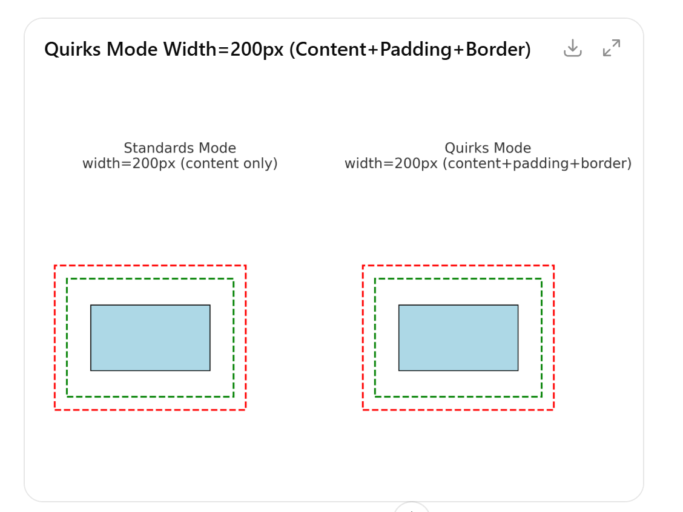

Here’s a visual to make it clearer 👇

* **Left (Standards Mode)** → the 200px width only covers the blue **content box**. Padding (green) and border (red) sit *outside* that width.
* **Right (Quirks Mode)** → the same 200px width ends up including content + padding + border, so the box actually shrinks inside.

That’s why forgetting <!DOCTYPE html> can throw off layouts—your boxes suddenly don’t size the way you expect.

here’s the low-down on doctypes and quirks mode in today’s browsers (Chrome, Firefox, Safari, Edge).

**🔑 General Rule**

* **Modern doctype** (<!DOCTYPE html>) → always triggers **Standards Mode** ✅
* **Missing doctype** → always triggers **Quirks Mode** ❌
* **Old/invalid doctypes** → can trigger **Quirks Mode** or a halfway state called **Almost Standards Mode**

**🕹️ Examples**

**✅ Standards Mode**

<!DOCTYPE html> <!-- HTML5+ -->

<!DOCTYPE HTML PUBLIC "-//W3C//DTD HTML 4.01//EN"

"http://www.w3.org/TR/html4/strict.dtd"> <!-- HTML 4.01 Strict -->

<!DOCTYPE html PUBLIC "-//W3C//DTD XHTML 1.0 Strict//EN"

"http://www.w3.org/TR/xhtml1/DTD/xhtml1-strict.dtd"> <!-- XHTML Strict -->

All of these force full modern rendering.

**❌ Quirks Mode**

<!-- No doctype at all -->

<html>

<!DOCTYPE HTML PUBLIC "-//W3C//DTD HTML 3.2 Final//EN"> <!-- Very old -->

<!DOCTYPE HTML PUBLIC "-//W3C//DTD HTML 4.01 Transitional//EN"> <!-- Transitional (without system ID URL) -->

Browsers intentionally fall back to legacy behavior.

**🤏 Almost Standards Mode**

<!DOCTYPE HTML PUBLIC "-//W3C//DTD HTML 4.01 Transitional//EN"

"http://www.w3.org/TR/html4/loose.dtd">

* Introduced for HTML 4.01 Transitional and XHTML Transitional doctypes.
* Behaves like Standards Mode for most things.
* Only difference: vertical spacing for inline images (like <img> inside text) can behave like quirks mode.

**🎯 Bottom Line**

* Use <!DOCTYPE html> — it’s clean, simple, and guarantees standards mode.
* Old doctypes are mostly museum pieces 🏛️.
* Quirks mode is still around, but only to keep 90s websites from exploding.